32.22: a) Absorbed light: 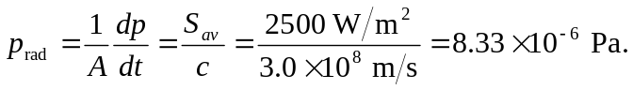
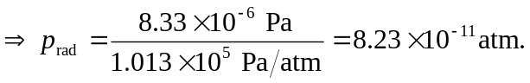
b) Reflecting light: 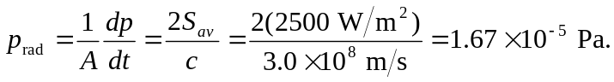
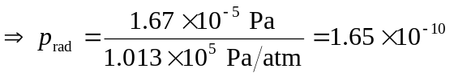atm. The factor of 2 arises because the momentum vector totally reverses direction upon reflection. Thus the change in momentum is twice the original momentum.
c) The momentum density 